ELITE ACADEMY
People · Progress · A Stronger You
ORGANIZATION CHART & COMMUNICATION CHANNELS
A level-by-level reference: who reports to whom, and how each level talks to the next
Field | Detail
Document Number | EA-COMM-REF-01
Version | 1.2
Effective Date | 13-Sep-2026
Related Documents | How We Work Together (EA-COMM-PLAY-01); Communication Procedure (EA-COMM-PROC-01)

This is a quick-reference companion to the Communication Procedure (EA-COMM-PROC-01), which contains the full detail, cascade rules, and open items. This document exists to be looked at, not just read — the org chart plus one channel table per level.

1. Organization Chart
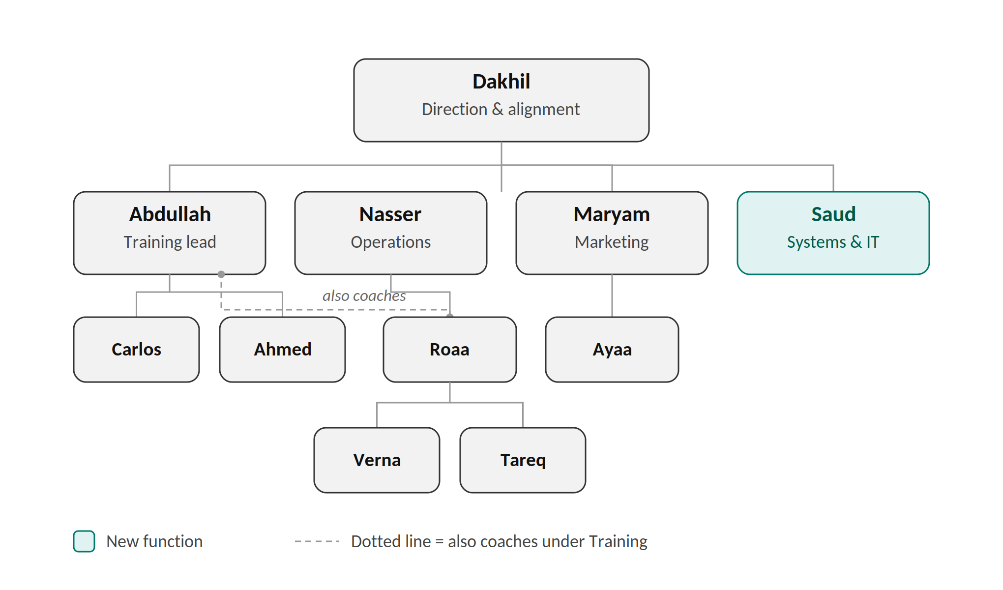
Carlos leads grappling and Ahmed leads striking under Abdullah, with all instructors reporting to him. Roaa reports to Nasser in Operations, sitting above Verna (Promenade, Hawalli) and Tareq (Bedaya), and also coaches under Abdullah in Training — shown by the dotted line. Ayaa implements marketing strategy under Maryam. Saud (highlighted) is the newly added Systems & IT function; his team, if any, is not yet defined.

2. Level 1 → Level 2 — Dakhil to Each Lead
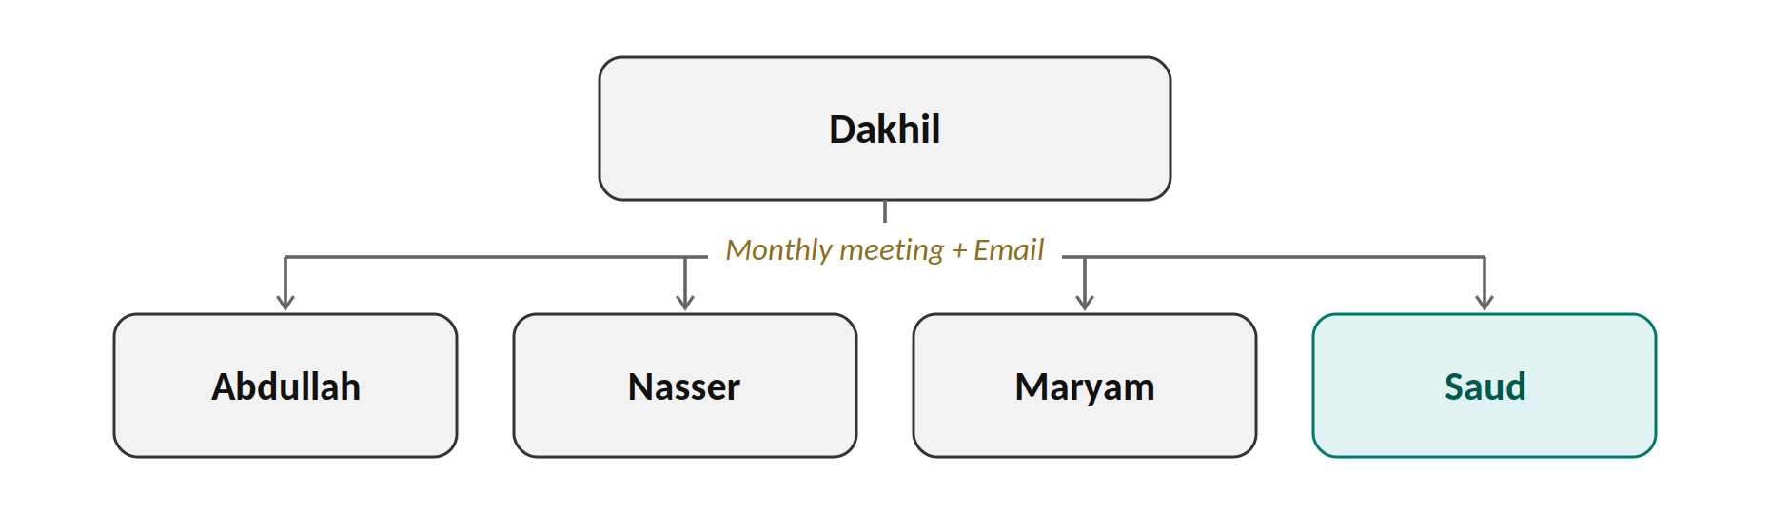

Monthly Standing Sync
From → To | What Moves | Channel / Frequency
Dakhil → Abdullah (Training) | Vision, strategic direction, training decisions. | Standing leads meeting, monthly.
Dakhil → Nasser (Operations) | Vision, strategic direction, operations/sales/branch decisions. | Standing leads meeting, monthly.
Dakhil → Maryam (Marketing) | Vision, strategic direction, marketing/messaging decisions. | Standing leads meeting, monthly.
Dakhil → Saud (Systems & IT) | Vision, strategic direction, systems/tools decisions. | Standing leads meeting, monthly.

Between Meetings
From → To | What Moves | Channel
Dakhil / Management → all 4 leads | Any decision or update that can't wait for the monthly meeting. | Email — forwarded by each lead to their own team (Section 4).

3. Level 2 ↔ Level 2 — Across the Leads
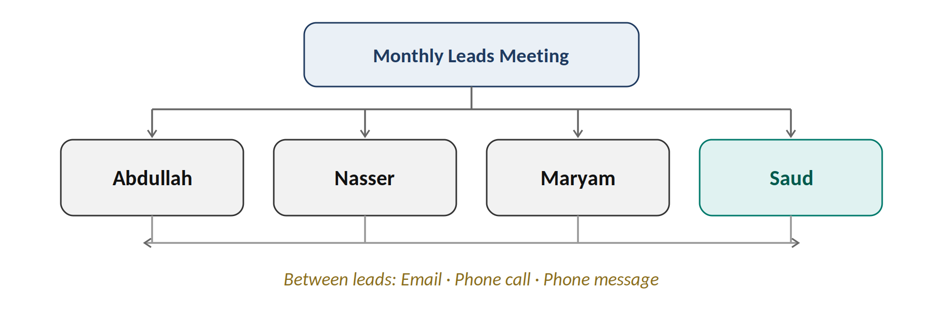
All four leads meet monthly alongside Dakhil (Section 2). Between meetings, and for the recurring handoffs below, leads reach each other by email, phone call, or phone message (SMS/WhatsApp) — whichever is fastest. The channel doesn't matter as much as the confirmation that closes it.
From → To | What Moves | Confirmation
Abdullah ↔ Maryam | Program knowledge and progress stories ↔ message alignment with what's taught. | Each side confirms receipt / accuracy.
Maryam ↔ Nasser | Campaigns → leads ↔ conversion results → better campaigns; class photos → Ayaa. | Nasser confirms leads logged; Maryam confirms photo/result receipt.
Abdullah ↔ Nasser | Attendance/progress/concerns ↔ bookings and member processes. | Each side confirms the update is logged.
Any lead → Saud | Requests for new tools, system changes, technical support. | Saud logs the request and confirms a timeline.
Saud → affected lead(s) | Notice before any system/tool change affecting their team. | Affected lead confirms awareness before go-live.

4. Level 2 → Level 3 — Leads to Their Subordinates
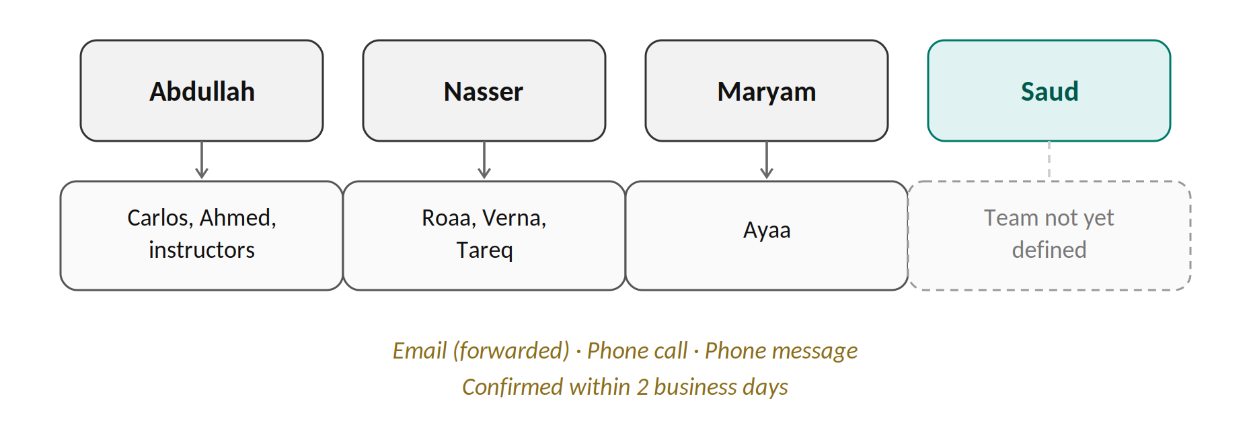
Each lead cascades what they receive within 2 business days. If it arrived by email, the lead forwards the same content rather than a paraphrase. A phone call or phone message works too, as long as confirmation still happens.
From → To | What Moves | Confirmation
Abdullah → Carlos, Ahmed, instructors | Training direction, program updates. | Verbal confirmation, logged by Abdullah.
Abdullah → Roaa (coaching) | Coaching direction and schedule; also copied to Nasser. | Roaa confirms; copy sent to Nasser.
Nasser → Verna, Tareq | Operations direction, bookings, member-process updates. | Verbal confirmation, logged by Nasser.
Nasser → Roaa (Operations) | Operations tasks and priorities; visible to Abdullah if it affects coaching. | Roaa confirms; Abdullah notified if relevant.
Maryam → Ayaa | Marketing strategy and campaign direction. | Ayaa confirms implementation.
Saud → his team | Not yet applicable — no subordinates defined yet. | To be added once scope/team are confirmed.

5. Level 3 → Level 2 → Level 1 — Reporting Upward
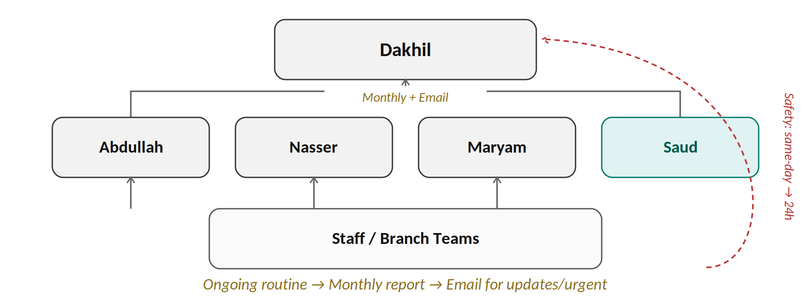

Monthly Reporting
From → To | What Moves | Frequency
Staff → their function lead | Attendance, progress, bookings, routine concerns. | Ongoing / per class or shift.
Abdullah → Dakhil | Attendance trends and unresolved concerns. | Monthly.
Nasser → Dakhil | Leads, conversion, retention. | Monthly.
Maryam → Dakhil | Campaign results and community growth. | Monthly.
Saud → Dakhil | Systems/IT status and open requests. | Cadence to be confirmed.

Between Reports & Urgent Escalation
From → To | What Moves | Channel / Timing
Any lead → Dakhil | Updates, issues, or other urgent matters between monthly reports. | Email, acknowledged by Dakhil / Operations Manager.
Any staff → their lead → Dakhil | Safety or conduct concerns. | Same-day to lead; escalated to Dakhil within 24 hours.

